Md. Ashir Rahman
ID: 20301079
Section: 18

5 layers' protocols' headers for request packet:

1.

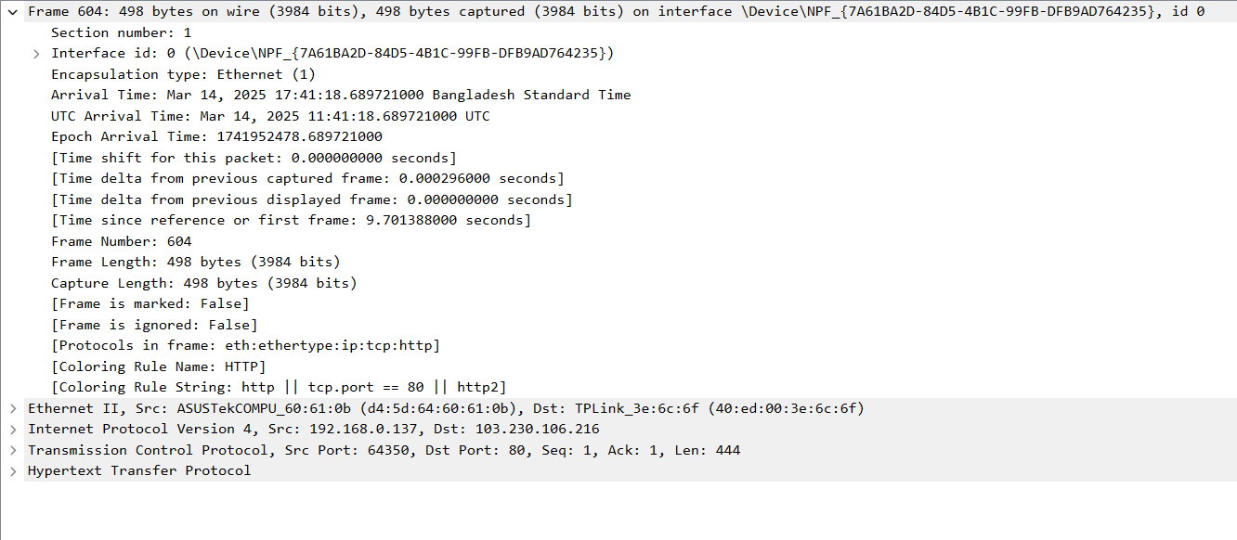

Frame 604 Overview: (Data Link Layer - OSI Layer 2)
- Captured Data: The total size of the frame is 498 bytes (3984 bits), captured on the interface \Device\NPF_{7A61BA2D-84D5-4B1C-99FB-DFB9A7D64235}.
- Arrival Time: The frame was captured on March 14, 2025, at 11:41:18.689721000 UTC.
- Epoch Time: The epoch time for this frame is 1714952478.689721000 seconds.
Frame Metadata:
- Frame Length: The captured frame length is 498 bytes (3984 bits).
- Time Delta Information:
Time from the previous frame: 0.000029000 seconds.
Time from the previous displayed frame: 0.000000000 seconds, indicating no visible difference.
Time since the first frame: 0.791388000 seconds.
- Frame Properties:
Marked: False (The frame is not marked with any flags).
Ignored: False (The frame is included for analysis).
Coloring Rule: HTTP (This indicates the packet is associated with HTTP traffic, likely web traffic).

2.

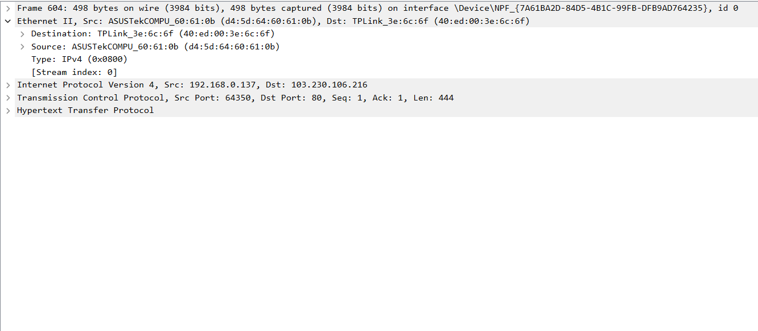
Ethernet II Header (Data Link Layer - OSI Layer 2)
- Source MAC Address (ASUSTekCOM_60:61:0b): This is the Media Access Control (MAC) address of the source device (ASUSTekCOM). It uniquely identifies the network interface on the sending device.
- Destination MAC Address (TPLink_3e:6c:6f): This is the MAC address of the destination device (TPLink). It uniquely identifies the network interface on the receiving device.
- Ethernet Type (IPv4 (0x0800)): This field indicates the protocol type encapsulated within the Ethernet frame. 0x0800 corresponds to IPv4, meaning the Ethernet frame is carrying an IPv4 packet.
- Stream Index (0): This is an internal reference used by packet analysis tools to organize packets in a particular conversation or flow. In this case, it indicates that the frame belongs to the first stream in the captured traffic.

3.

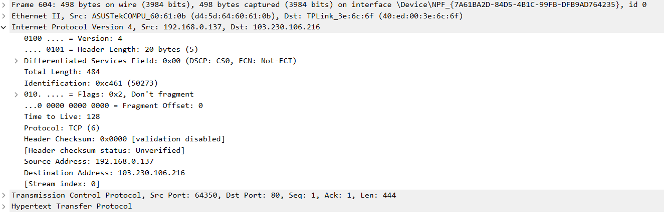
IPv4 Header (Network Layer - OSI Layer 3)
- Version: 4 (IPv4)
- Header Length: 20 bytes
- Differentiated Services Field: 0x00 (Default service, no explicit congestion notification)
- Total Length: 484 bytes (Total size of the packet, including header and data)
- Identification: 0x461 (50273) (Unique identifier for packet fragmentation)
- Flags: 0x2 (Don't Fragment flag enabled)
- Fragment Offset: 0 (No fragmentation)
- Time to Live (TTL): 128 (Number of hops the packet can make before being discarded)
- Protocol: TCP (The packet contains a TCP segment)
- Checksum: 0x0000 (Validation disabled)
- Source Address: 192.168.0.137 (IP of the sender)
- Destination Address: 103.230.106.216 (IP of the receiver)
- Stream Index: 0 (Indicates the stream or flow of the packet)

4.

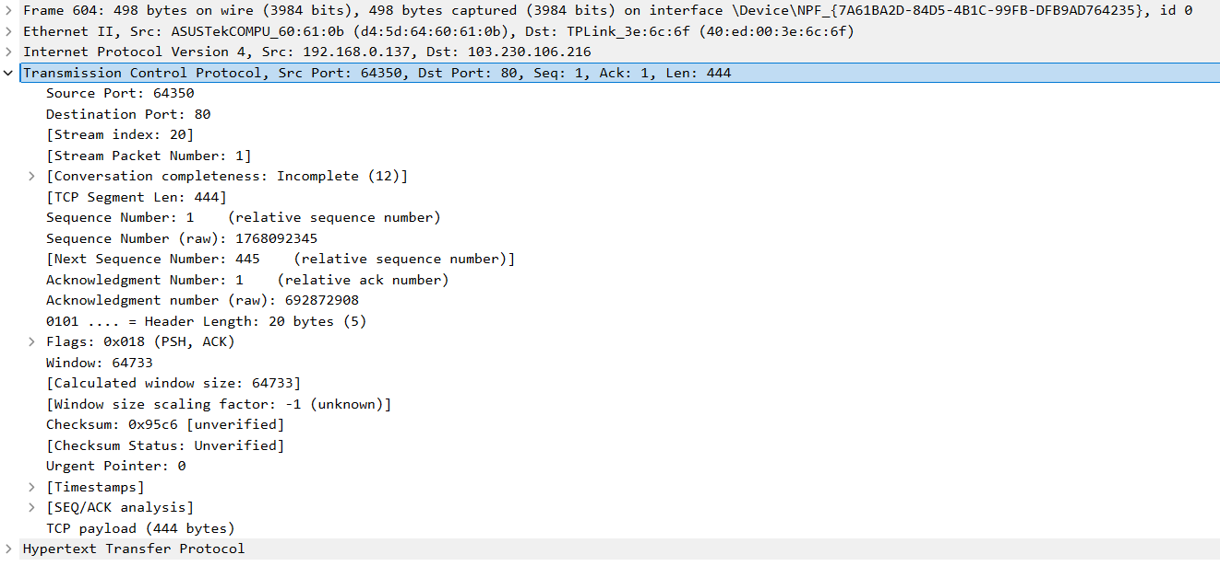
TCP Header (Transport Layer - OSI Layer 4)
- Source Port: 64538 – The port on the source device initiating the connection.
- Destination Port: 80 – The port on the destination device receiving the request (commonly used for HTTP traffic).
- Sequence Number: 1 (relative sequence number), 176892245 (raw sequence number) – This indicates the position of the first byte of data in the current segment.
- Acknowledgment Number: 1 (relative acknowledgment number), 692879088 (raw acknowledgment number) – This number refers to the byte the sender is expecting next.
- Header Length: 20 bytes – Standard length for the TCP header without any options.
- Flags: 0x018 – Indicates the PSH (Push) and ACK (Acknowledgment) flags are set, signaling that data should be immediately pushed to the receiving application and acknowledgment is being sent.
- Window Size: 64733 – Specifies the amount of data that the receiver is willing to accept.
- Checksum: 0x0c56 (unverified) – Used for error-checking the TCP segment.
- Urgent Pointer: 0 – No urgent data in this segment.
- Timestamps: Included in the analysis for timing synchronization (though not explicitly shown in the screenshot).

5.

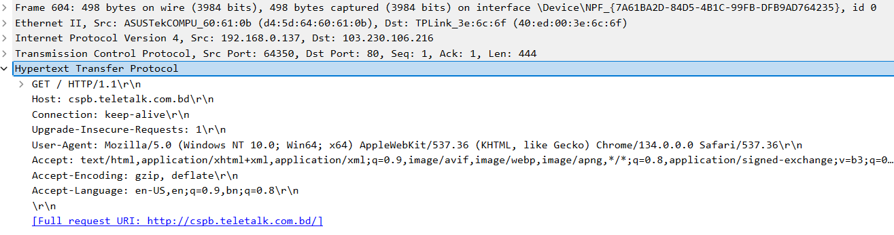

5 layers' protocols' headers for response packet:

1.
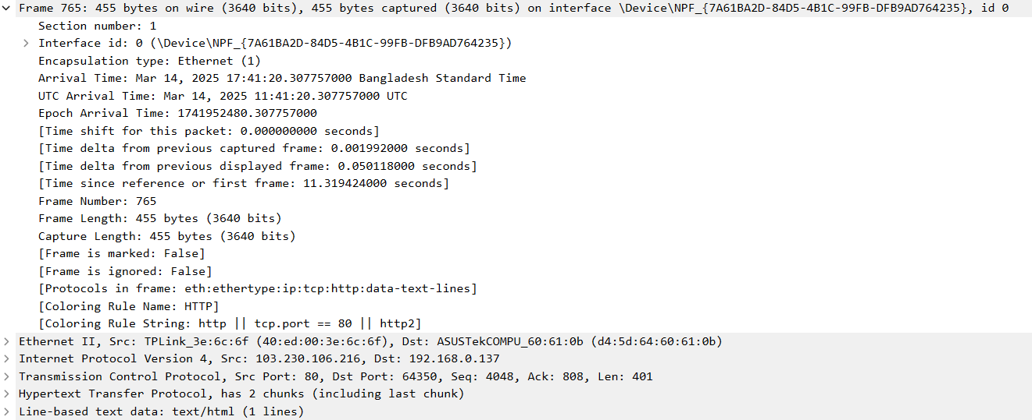
HTTP Request Summary (Application Layer - OSI Layer 7)
- Request Method: GET (Requesting data from the server).
- Protocol: HTTP/1.1 (Version of HTTP).
- Host: cspb.teletalk.com.bd (Target server domain).
- Connection: keep-alive (Keep the TCP connection open for future requests).
- Upgrade-Insecure-Requests: 1 (Request to upgrade to a secure connection if available).
- User-Agent: Identifies the browser and OS (Chrome on Windows 10).
- Accept: Specifies acceptable content types (HTML, XML, images).
- Accept-Encoding: Supports compressed content (gzip, deflate).
- Accept-Language: Prefers content in English (US).

Request URI:
- The full requested URI: http://cspb.teletalk.com.bd/ (Homepage of the server).

2.

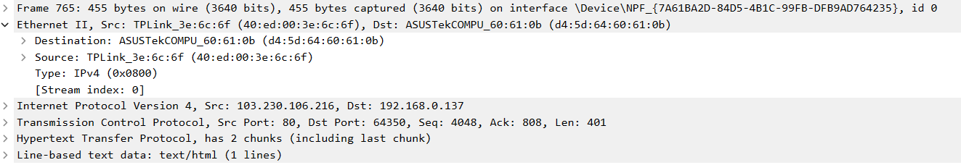
Ethernet Frame (Data Link Layer - OSI Layer 2)
- Source MAC Address: TPLink_3e:6c:6f (This is the MAC address of the device sending the frame).
- Destination MAC Address: ASUSTekCOM_60:61:0b (This is the MAC address of the device receiving the frame).
- Ethernet Type: IPv4 (0x0800) (Indicates that the frame is carrying an IPv4 packet).
- Stream Index: 0 (Indicates this frame is part of the first stream in the captured traffic).

3.

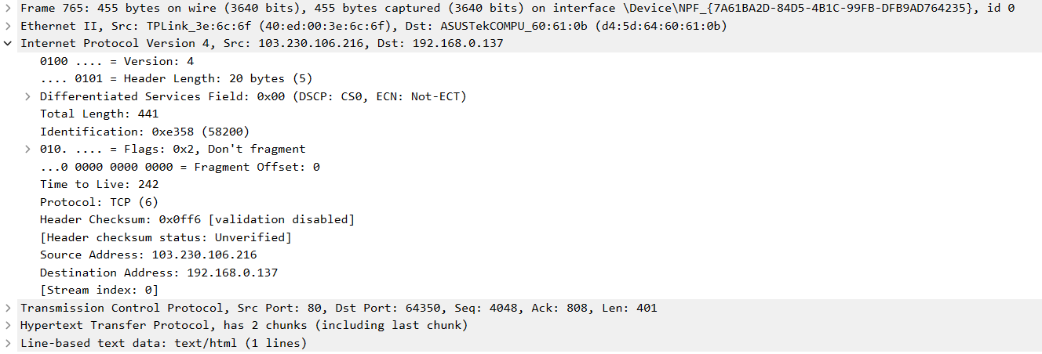
IPv4 Header (Network Layer - OSI Layer 3)
- Version: 4 (IPv4)
- Header Length: 20 bytes
- Differentiated Services Field: 0x00 (DSCP: CS0, ECN: Not-ECT). This field is used for traffic management and QoS (Quality of Service).
- Total Length: 441 bytes (This includes the header and the payload).
- Identification: 0x358 (856) (A unique identifier for this packet used in case of fragmentation).
- Flags: 0x2 (Don’t Fragment flag is set, indicating the packet should not be fragmented during transmission).
- Fragment Offset: 0 (No fragmentation offset).
- Time to Live (TTL): 242 (The number of hops this packet can make before being discarded).
Protocol: TCP (6) (The payload is a TCP segment, as indicated by the protocol number 6).
- Header Checksum: 0x0ff6 (Used to verify the integrity of the IPv4 header, but validation is disabled here).
- Source Address: 103.230.106.216 (The IP address of the sender).
- Destination Address: 192.168.0.137 (The IP address of the recipient).
- Stream Index: 0 (Indicates the stream this packet belongs to).

4.

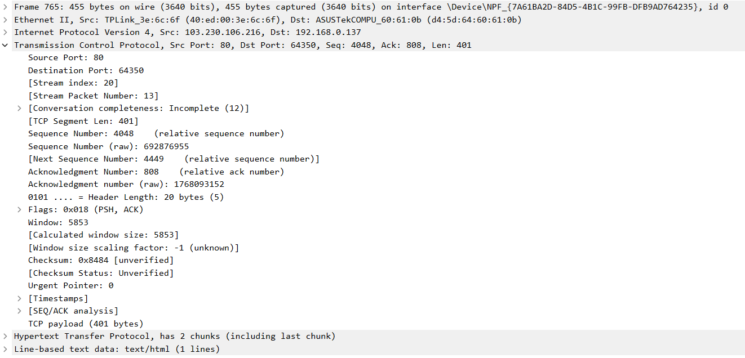
TCP Header (Transport Layer - OSI Layer 4)
- Source Port: 80 – The source port is 80, indicating the server is using the default port for HTTP traffic.
- Destination Port: 64350 – The destination port is 64350, the port number on the receiving device for this communication.
- Sequence Number:
Relative Sequence Number: 4048
Raw Sequence Number: 69276955
This represents the position of the first byte of data in the current segment.
- Next Sequence Number: 4449 (Relative Sequence Number) – Indicates the next expected sequence number for data transmission.
- Acknowledgment Number:
Relative Acknowledgment Number: 808
Raw Acknowledgment Number: 176893152
This indicates the next byte expected from the other side in the conversation.
- Header Length: 20 bytes – Standard length for a TCP header without any additional options.
- Flags: 0x018 (PSH, ACK) – The PSH (Push) flag instructs the receiving side to push the data to the application immediately, while the ACK (Acknowledgment) flag indicates the acknowledgment of the received data.
- Window Size: 5853 – The window size indicates how much data the receiver is willing to accept in this transmission.
- Checksum: 0x8444 (Unverified) – Used for error-checking the TCP segment.
- Urgent Pointer: 0 – No urgent data in this segment.
- TCP Payload: 401 bytes – The actual data being transmitted in this TCP segment, excluding the header.
- Incomplete (12) – Indicates that this conversation is incomplete and there are further packets to follow for this connection.

5.

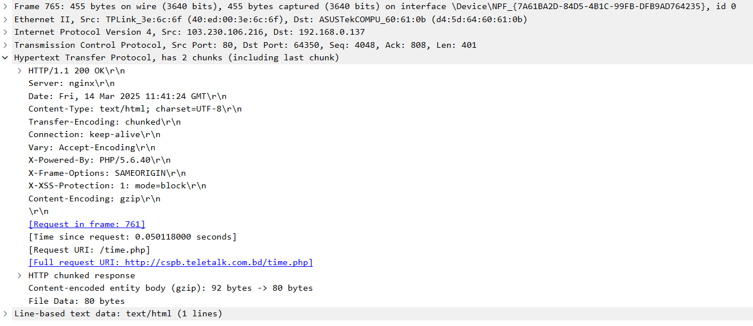
HTTP Response Summary (Application Layer - OSI Layer 7)
- Status: HTTP/1.1 200 OK – The request was successful.
- Server: nginx – The web server handling the request.
- Date: Fri, 14 Mar 2025 11:41:24 GMT – The time the response was generated.
- Content-Type: text/html; charset=UTF-8 – The content is HTML with UTF-8 encoding.
- Transfer-Encoding: chunked – The response body is sent in chunks.
- Connection: keep-alive – The connection remains open for further requests.
- Content-Encoding: gzip – The response body is compressed using gzip.
- Request URI: /time.php – The requested resource.
- Full Request URI: http://cspb.teletalk.com.bd/time.php – The complete URL.

